**Chapter 3**

**SOFTWARE DESIGN**

* 1. **Class Diagram**

A Class diagram simply depicts interaction between objects in a sequential order i.e. the order in which these interactions take place. We can also use the terms event diagrams or event scenarios to refer to a class diagrams describe how and in what order the objects in a system function.

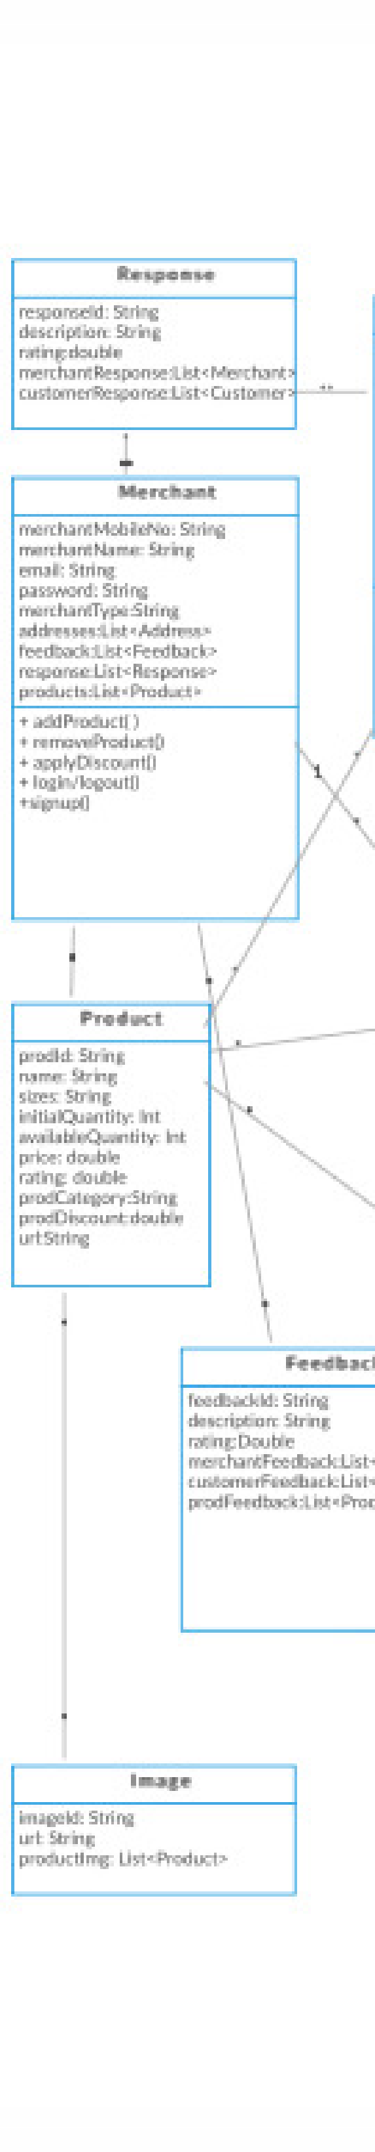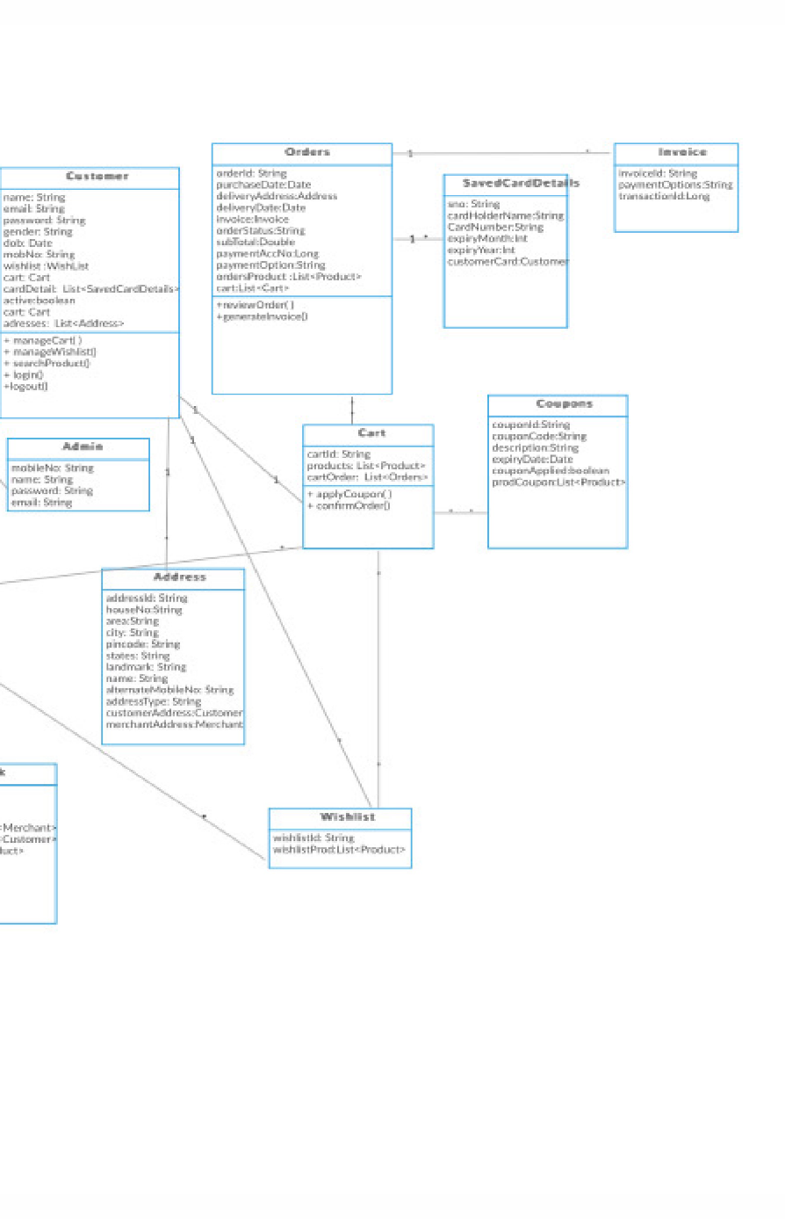

Figure 3.1 Class Diagram